Steg 1→ Skapa relation från Presentation till API

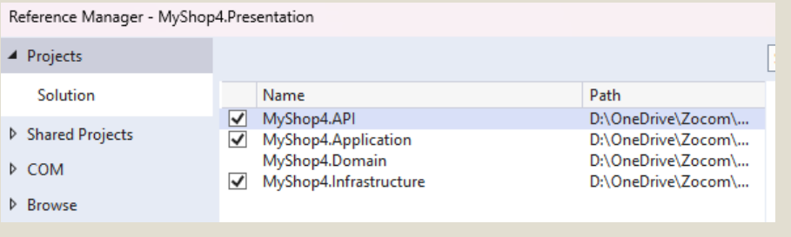

Step 1- Completed

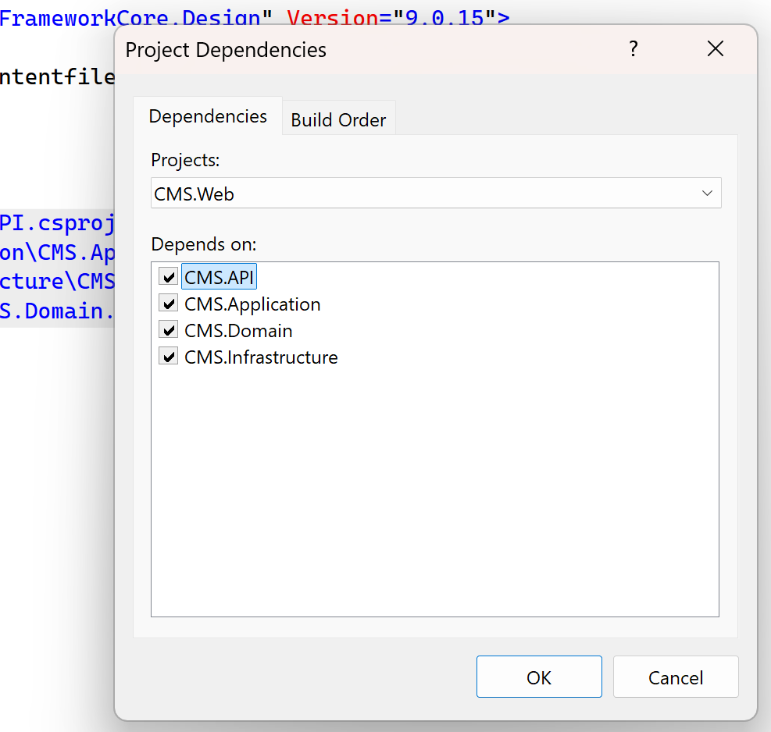

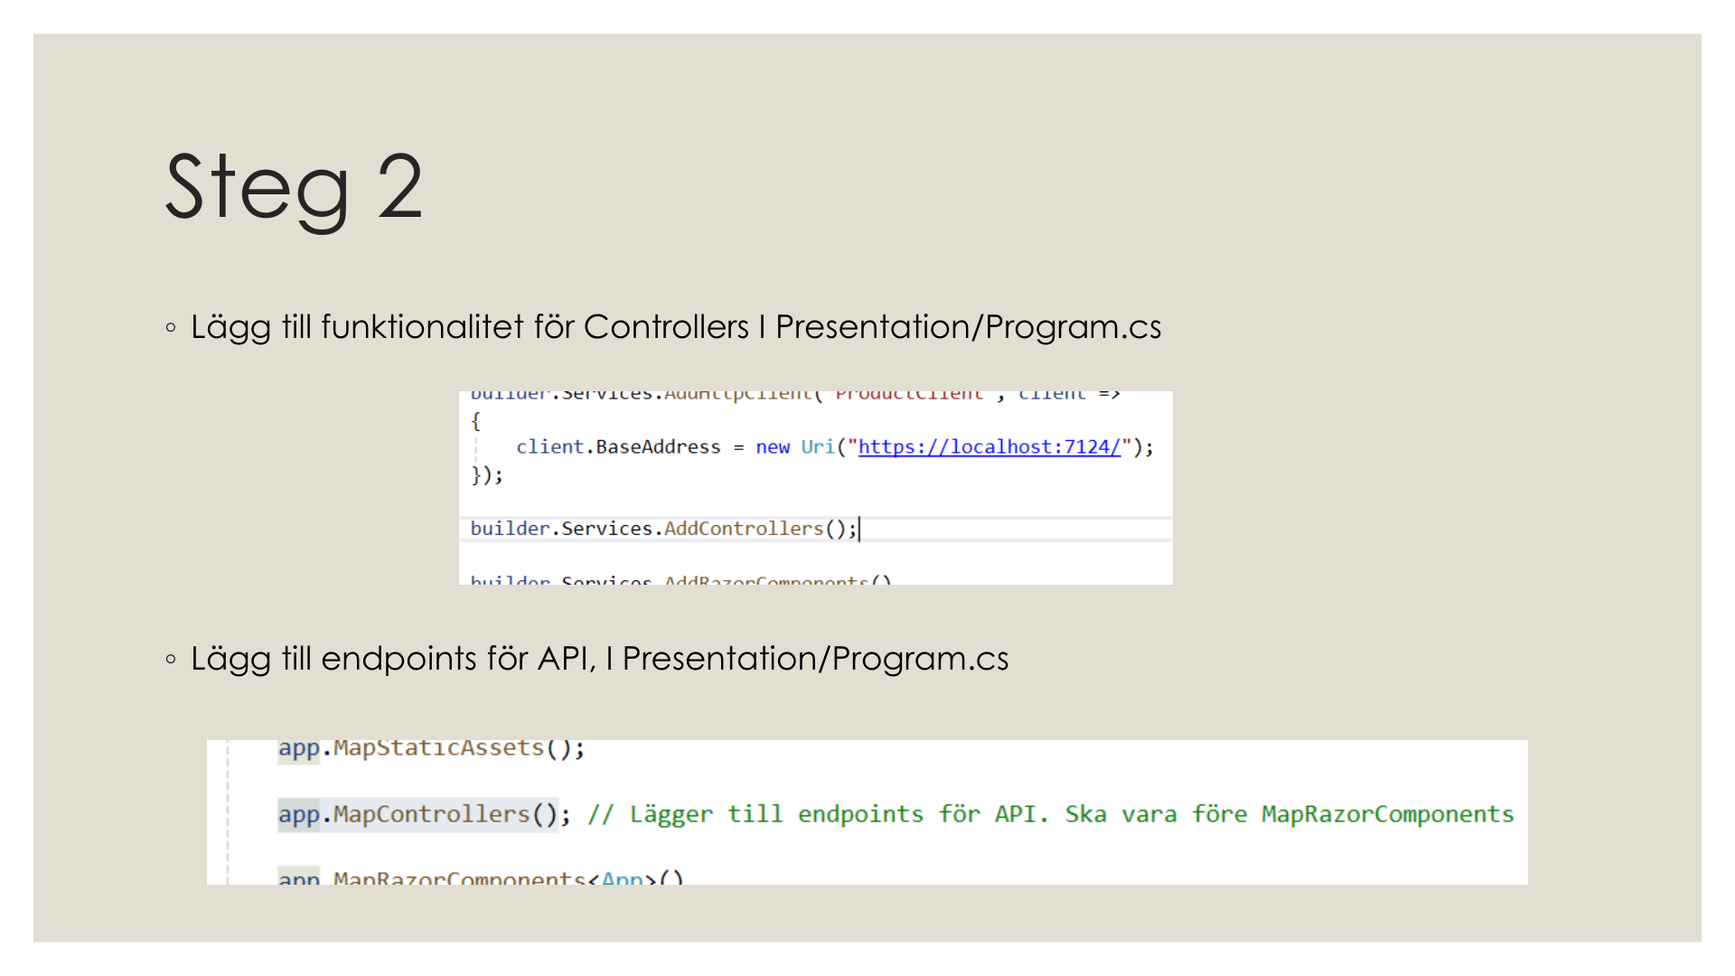
Step 2:
CMS.Web\Program.cs Line 53-55
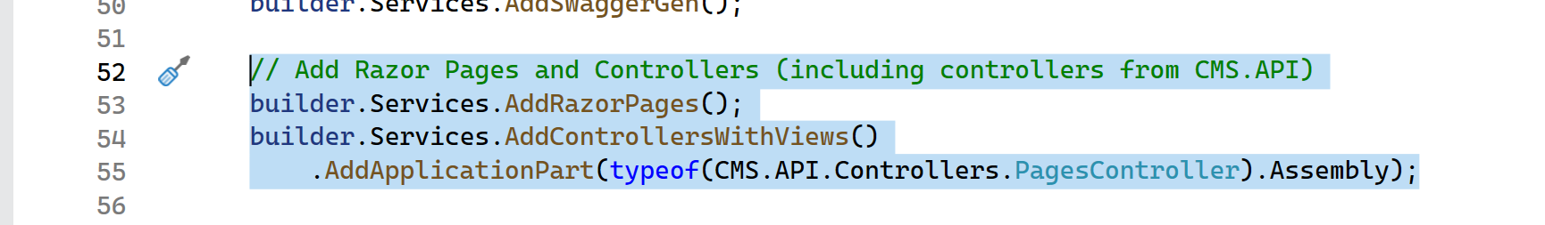

CMS.Web\Program.cs lines 83


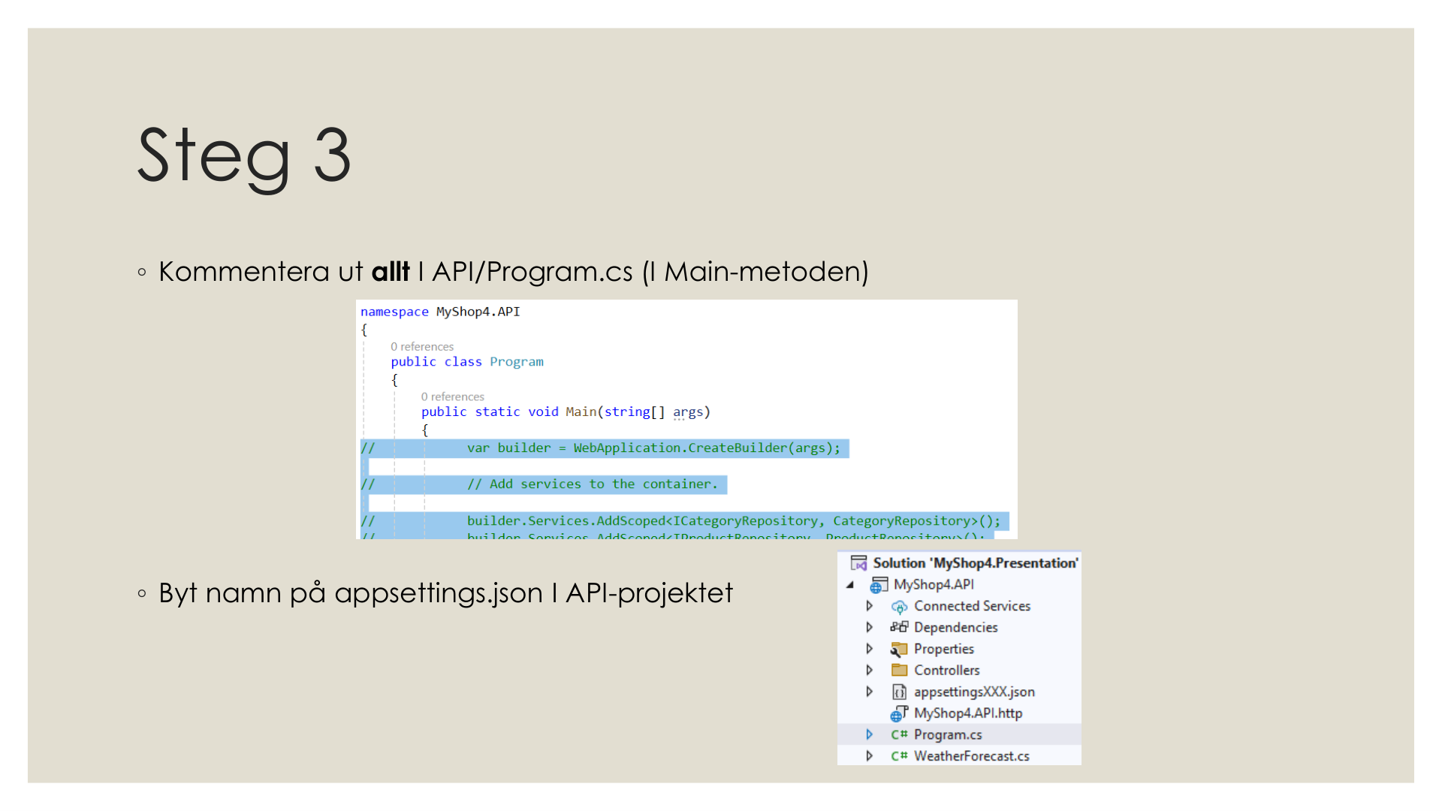

CMS.API\Program.cs all commented
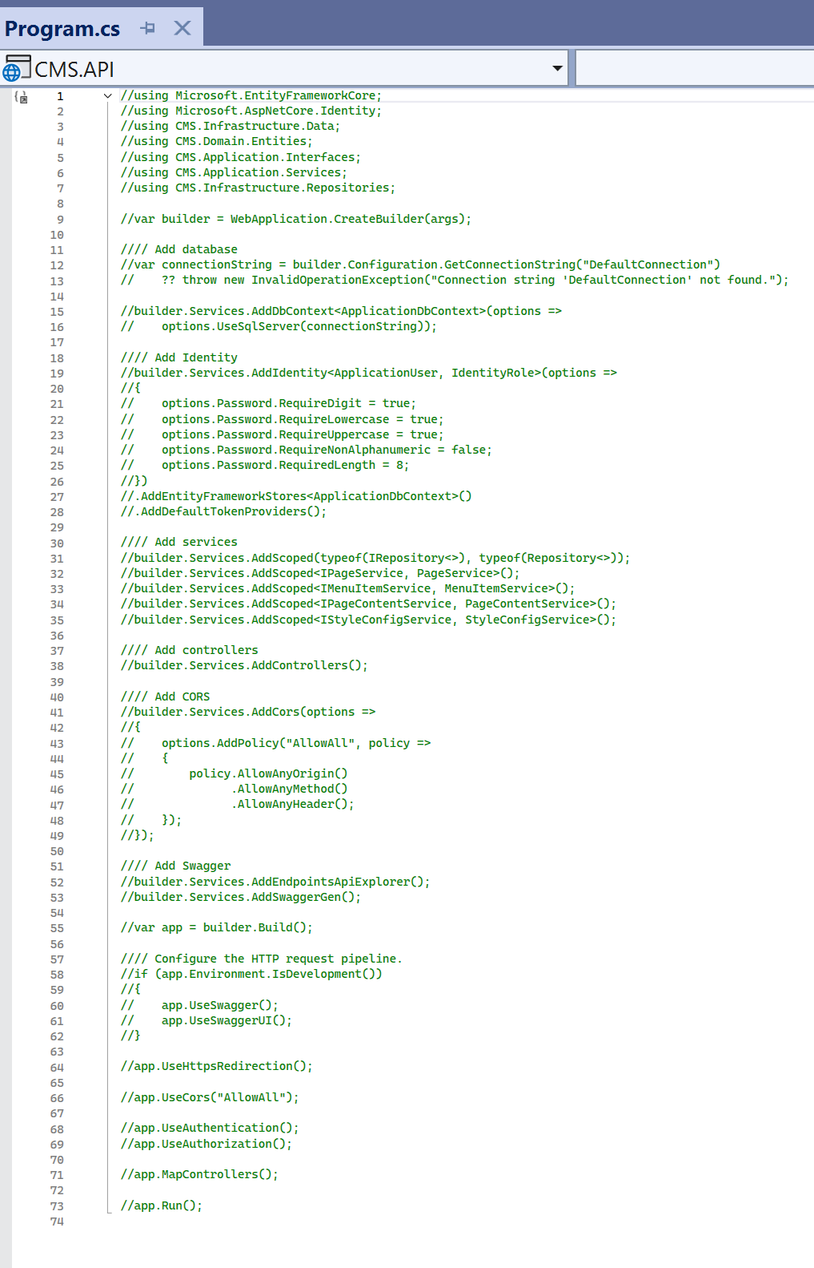

Appsettings.json disabled
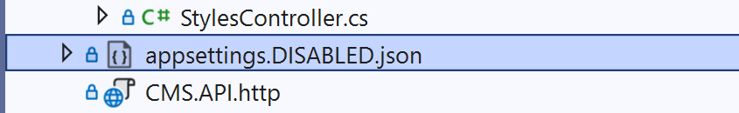

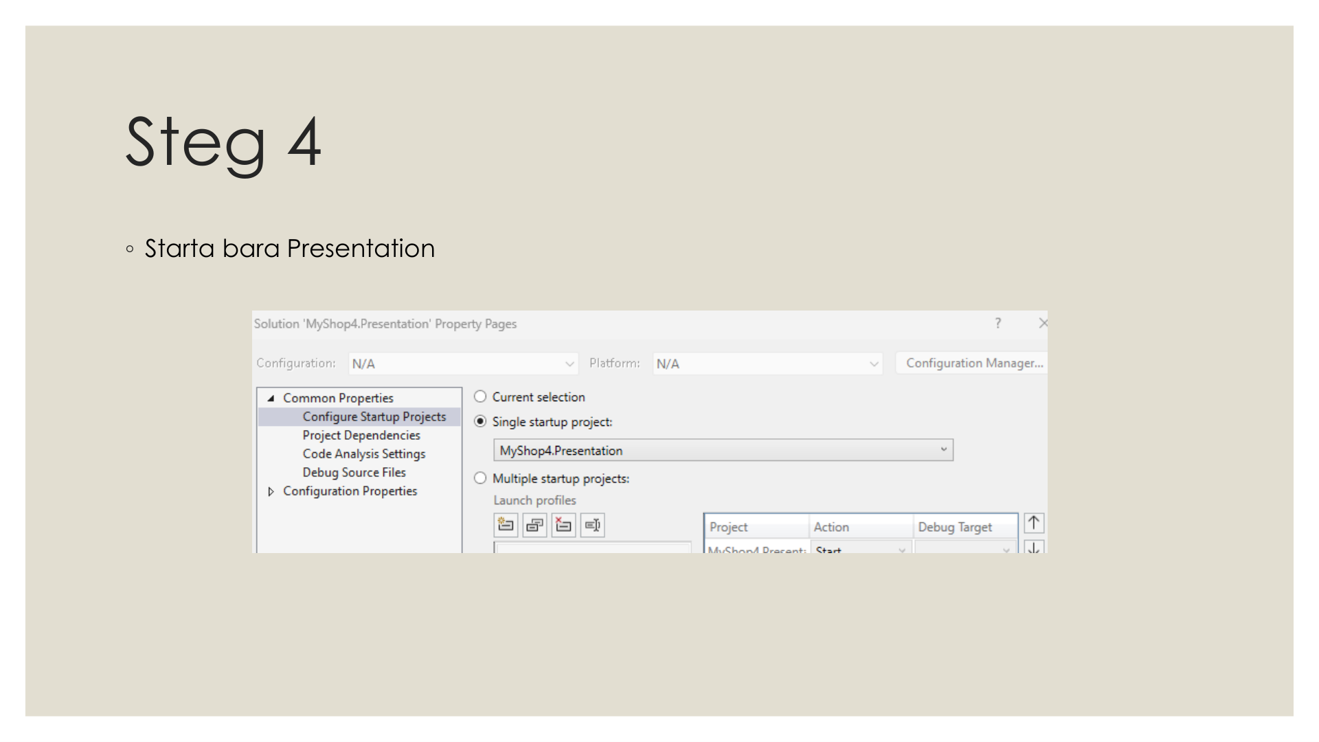

Startup Project Set to CMS.Web

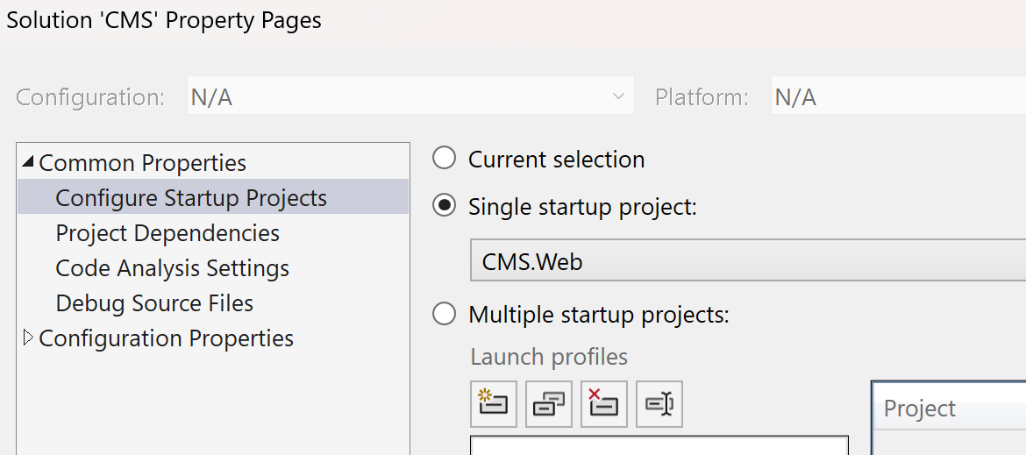

CMS.API project change to class library
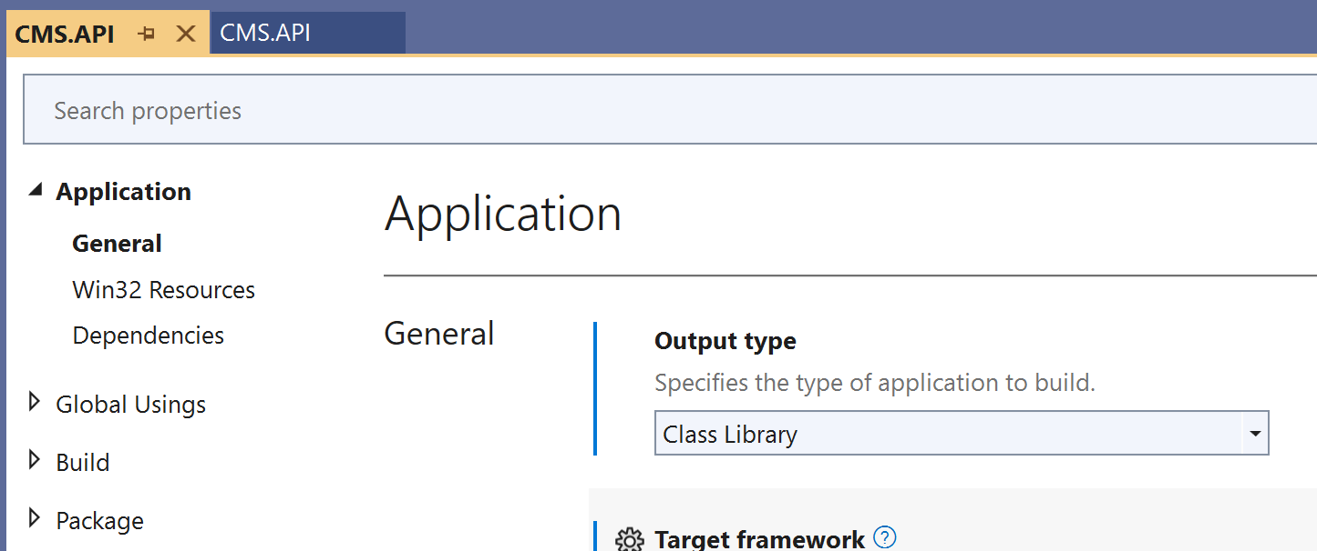

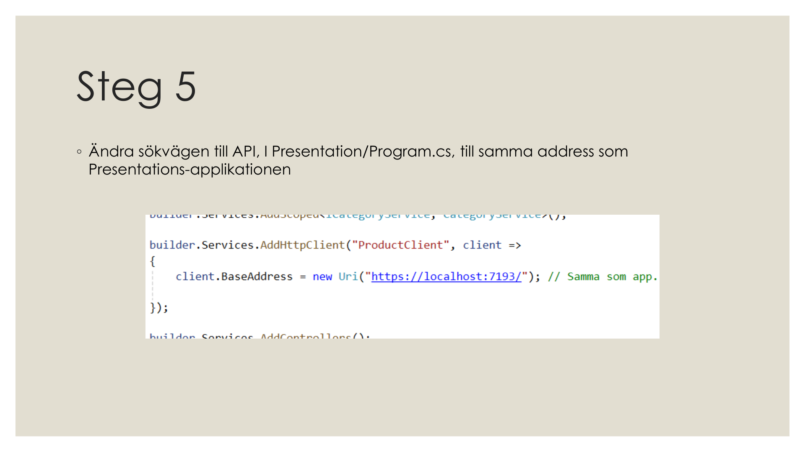
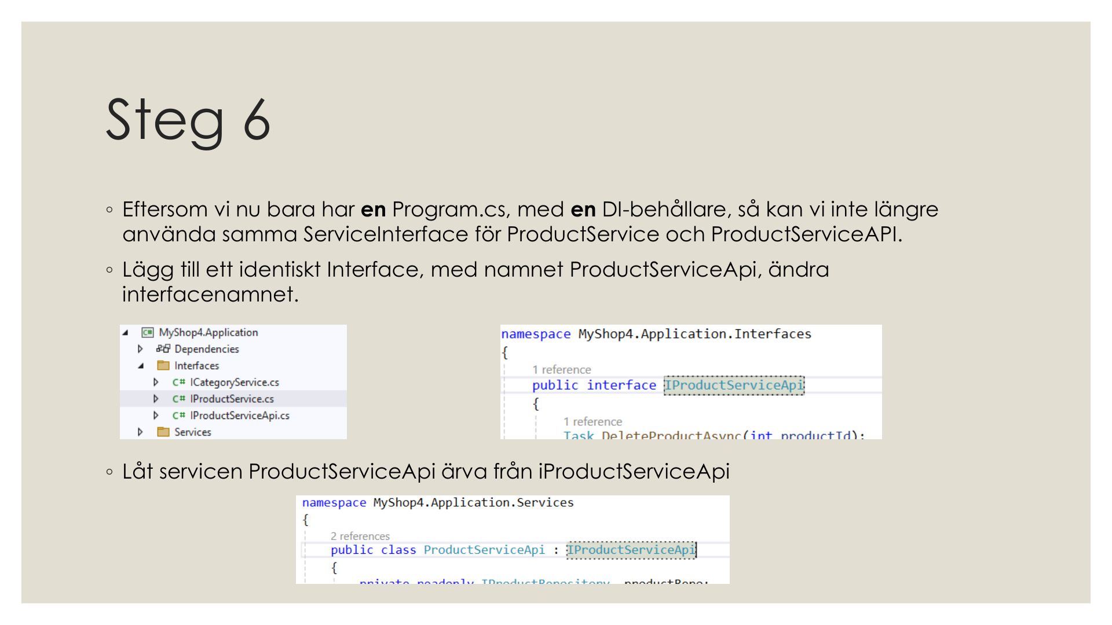
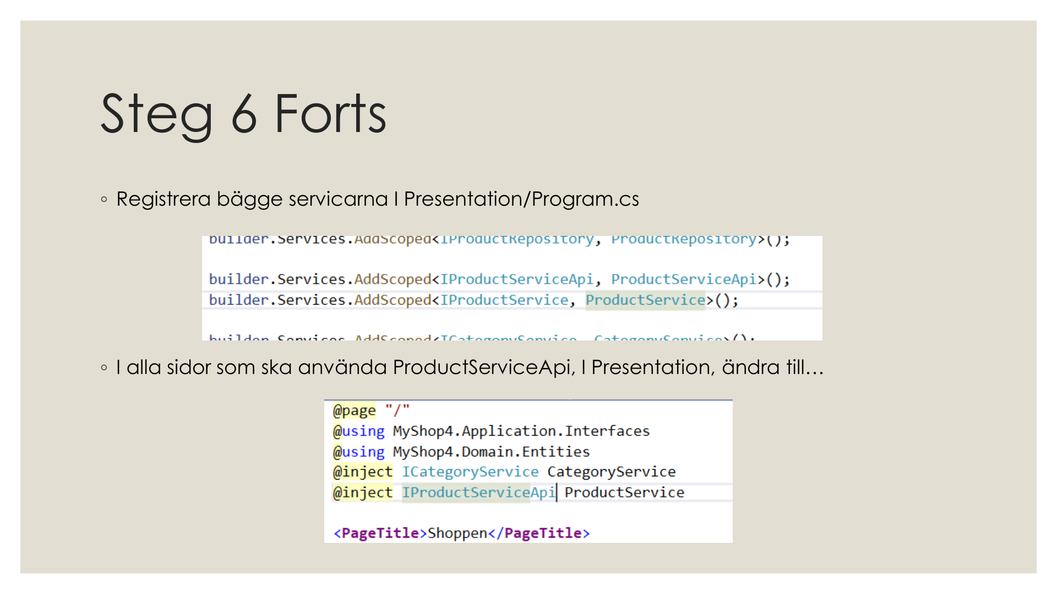

Step 5 & 6 Not needed — no HttpClient required in Razor Pages.

CMS.Web is using Razor Pages inject the application services directly using dependency injection. Which do not make HTTP calls to the API. Because of this we do not need an HttpClient or a base address configuration.

The API controllers exist and are fully working at /api/pages, /api/menuitems etc. Steps 1 to 4 are all implemented — CMS.API is a class library, its Program.cs is commented out, appsettings.json is renamed, and the controllers are loaded into CMS.Web using AddApplicationPart."

